BUSINESS DAY

J.&J. to Pay $2.2 Billion in Risperdal Settlement
By KATIE THOMASNOV. 4, 2013

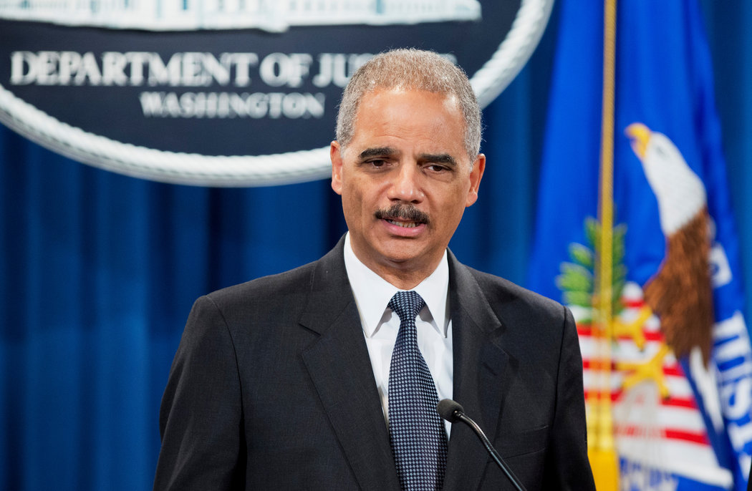
Eric H. Holder Jr., the United States attorney general, said the company put at risk the health of vulnerable members of society. CreditManuel Balce Ceneta/Associated Press

Johnson & Johnson has agreed to pay more than $2.2 billion in criminal and civil fines to settle accusations that it improperly promoted the antipsychotic drug Risperdal to older adults, children and people with developmental disabilities, the Justice Department said on Monday.
The agreement is the third-largest pharmaceutical settlement in United States history and the largest in a string of recent cases involving the marketing of antipsychotic and anti-seizure drugs to older dementia patients. It is part of a decade-long effort by the federal government to hold the health care giant — and other pharmaceutical companies — accountable for illegally marketing the drugs as a way to control patients with dementia in nursing homes and children with certain behavioral disabilities, despite the health risks of the drugs.
The settlement, which requires the approval of a federal judge, will also resolve accusations that the company inappropriately promoted two other drugs, the heart-failure drug Natrecor and Invega, a newer antipsychotic drug.
Much of the conduct highlighted in the case, which for Risperdal extends from 1999 through 2005, occurred while Alex Gorsky was vice president for sales and marketing and later president of the company’s pharmaceutical unit, Janssen. Mr. Gorsky became chief executive of Johnson & Johnson last year. Risperdal, which has lost its patent protection, was once one of the company’s best-selling drugs.
In a news conference announcing the settlement, Eric H. Holder Jr., the United States attorney general, said the company’s practices “recklessly put at risk the health of some of the most vulnerable members of our society — including young children, the elderly and the disabled.”
As part of the settlement, Johnson & Johnson has agreed to plead guilty to a criminal misdemeanor, acknowledging that it improperly marketed Risperdal to older adults for unapproved uses. It did not admit to wrongdoing for the civil portion of the settlement, which involves claims that the company promoted the drug’s use in children and the developmentally disabled, as well as accusations that it paid kickbacks to doctors and pharmacists in exchange for writing more prescriptions. The company will pay criminal fines and forfeiture of $485 million and civil penalties of $1.72 billion. The civil settlement also resolves similar accusations brought by 45 states.
Johnson & Johnson said on Monday that it stood by the safety and efficacy of Risperdal and was trying to put the chapter to rest. “This resolution allows us to move forward and continue to focus on delivering innovative solutions that improve and enhance the well-being of patients around the world,” Michael Ullman, the company’s vice president and general counsel, said in a statement.
But some called into question the extent to which the company could move on, given that Mr. Gorsky was now chief executive. “Stockholders and patients will pay the price for the fraud,” said Patrick Burns, co-director of Taxpayers Against Fraud, an advocacy group for corporate whistle-blowers. “Mr. Gorsky, however, gets to keep his job at Johnson & Johnson and all his bonuses.” Mr. Burns has called on federal officials to hold executives more directly accountable in such cases.
Ernie Knewitz, a spokesman for Johnson & Johnson, noted that the misdemeanor charge was being entered on behalf of the company and no individuals were charged with wrongdoing. “Mr. Gorsky has been an outstanding Johnson & Johnson leader for more than 20 years,” he said.
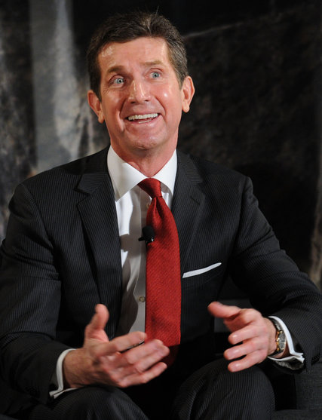
Alex Gorsky is chief executive of Johnson & Johnson.CreditBryan Bedder/Getty Images
Johnson & Johnson officials tried to expand the market for Risperdal to older dementia patients soon after the drug was approved in 1993 to treat symptoms of psychiatric disorders, according to federal court filings. The drug, whose generic name is risperidone, was primarily tested in schizophrenia patients, and the Federal Drug Administration repeatedly rejected efforts by the company to expand the drug’s use to older dementia patients, according to the filings.
But Johnson & Johnson, federal officials said, actively pursued the market for geriatric patients. The company created a dedicated sales force, ElderCare, to promote the drug and others to doctors who primarily treated older patients.
The drug, the company claimed, could address symptoms that made treating these patients a challenge, especially in a nursing home setting, including agitation, confusion, hostility and impulsiveness. The company’s sales brochures highlighted these symptoms and minimized the fact that the drug was approved to treat schizophrenia, according to federal documents.
Federal officials said the company knew that Risperdal posed serious health risks for older adults, like an increased risk of strokes, but it played them down. The drug’s label was later updated to warn against the use of the drug in older patients with dementia.
During this period, Risperdal was among the company’s top-selling drugs. In 2004, for example, Risperdal brought in $3.1 billion in sales, accounting for about 5 percent of Johnson & Johnson’s total revenue that year, according to company filings.
Johnson & Johnson was not the only company marketing drugs to older dementia patients and the long-term care facilities where they were treated. Within the last five years, federal officials have reached similar agreements regarding Zyprexa, made by Eli Lilly; Seroquel, made by AstraZeneca; and Depakote, by Abbott, which is now AbbVie.
Federal prosecutors also say, as part of the civil settlement, that Johnson & Johnson promoted the use of Risperdal in people with mental disabilities and children, even though the company did not receive F.D.A. approval to market to children until 2006. Janssen told its sales representatives to visit child psychologists and mental health facilities that mainly focused on children, promoting the drug as a safe treatment for disorders like attention deficit hyperactivity disorder and obsessive-compulsive disorder, the government said.
Johnson & Johnson knew that children were susceptible to certain health risks from taking Risperdal, including the possibility that boys could develop breasts through elevated production of the hormone prolactin, federal officials said.
Monday’s announcement is the latest in a series of large settlements involving pharmaceutical companies and allegations of improper marketing. Last year, the British drug maker GlaxoSmithKline reached a settlement of $3 billion over the marketing of several drugs, and in 2009, Pfizer settled with the government for $2.3 billion in a deal involving the painkiller Bextra, which is no longer on the market.
“As a group these have kind of sent a message to the pharmaceutical industry that this kind of widespread fraud and disregard for F.D.A. regulations isn’t going to be tolerated,” said David Stone, a lawyer on a team representing the four whistle-blowers who sued to bring the Johnson & Johnson accusations to light. They will share a reward of $112 million from the federal portion of the settlement. Still, Mr. Stone said, the incentives to commit wrongdoing remain. “The more they can expand market share, the more money they make.”
A version of this article appears in print on November 5, 2013, on page B1 of the New York edition with the headline: J.&J. to Pay $2.2 Billion In Risperdal Settlement. Order Reprints| Today's Paper|Subscrib

